Lab3 - Guideline

Topics
- VLANs and Trunking
- VTP protocol
- Inter-VLAN routing: Router, Sw L3

Step1: create the below depicted topology using Cisco Packet Tracer simulator
Step2: set the links between the switches in trunk mode
Step3: create VLAN 10 (name IT), 20 (name Staff), 30, 40, 50 only on the L3 Switch
Step4: propagate VLANs’ information using VTP protocol
Step5: assign IP addresses as shown below
Step6: set the appropriate switches’ interfaces in access mode
Step7: test the connectivity

Laboratory test configuration:

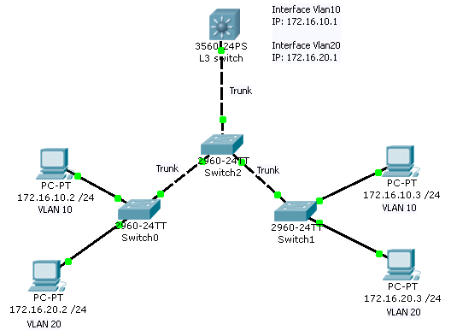

- VLANs and Trunking

Commands Used:

! Create VLANs 10 - 50

Switch>enable
Switch#configure terminal

Switch(config)#vlan 10
Description: Global configuration command that creates VLAN 10

Switch(config-vlan)#name IT
Description: Assigns a name to the VLAN

Switch#show vlan brief
Description: Displays VLANs information (the contents of the vlan.dat file )

Set interfaces in TRUNK or ACCESS mode

Switch(config)#interface fa 0/1

Switch(config-if)#switchport mode access
Switch(config-if)#switchport access vlan 10
Description: Configures a port as an access port and assigns VLAN 10 to an access port

Switch(config-if)#switchport mode trunk
Description: Configures a port as a trunk port

Switch#show interfaces trunk
Description: Displays trunking information for the switch

- VTP Protocol

VTP = VLAN Trunking Protocol

- allows for the propagation of VLAN’s from a single switch to multiple switches (Server-Client architecture) in the same VTP Domain (domain = share the same VLANs)

VTP Server switch - centralized point of management in the network for VLAN definition and propagation. Define all VLANs on the server.
VTP Client switch - learns its VLAN information from the VTP Server in its specified VTP Domain.
VTP Transparent switch - does not participate in VTP. A VTP transparent switch does not advertise its VLAN configuration and does not synchronize its VLAN configuration based on received advertisements, but transparent switches do forward VTP advertisements that they receive out their trunk ports in VTP Version 2.

Commands Used:

Switch#show vtp status
Description: view the current settings configured for VTP

Switch(config)# vtp mode server
or
Switch(config)# vtp mode client
or
Switch(config)# vtp mode transparent
Description: set VTP switch type.

Switch(config)# vtp domain CND
Description: set the VTP domain name. Switches sharing the same VLANs must use the same domain name.

- On the Server switch:
  - Define the VLANs to be propagated using VTP.
  - Set the domain name
- Set the links between switches in mode trunk
- Set the other switches:
  - in Client mode, to synchronize with the Server.
  - Set the domain name
- Check VTP status on all switches.

C. Inter-Vlan routing using a L3 Switch

Commands Used:

SwitchL3(config)#ip routing
Description: Enable routing on the switch

SwitchL3 (config)#interface fa 0/1
SwitchL3 (config-if)#switchport trunk encapsulation dot1q
SwitchL3 (config-if)#switchport mode trunk
Description: Set an interface in mode trunk on Layer3 Switch

Assign IP address to VLAN interfaces, following the next example:

SwitchL3 (config)#interface Vlan10
SwitchL3 (config-if)#ip address 172.16.10.1 255.255.255.0
SwitchL3 (config-if)#no shutdown
Description: Configure the VLAN interfaces with the IP addresses

SwitchL3 #show ip route
Description: Visualize the routing table

Set the Default Gateway IP on the host computers.

Test the connectivity.

